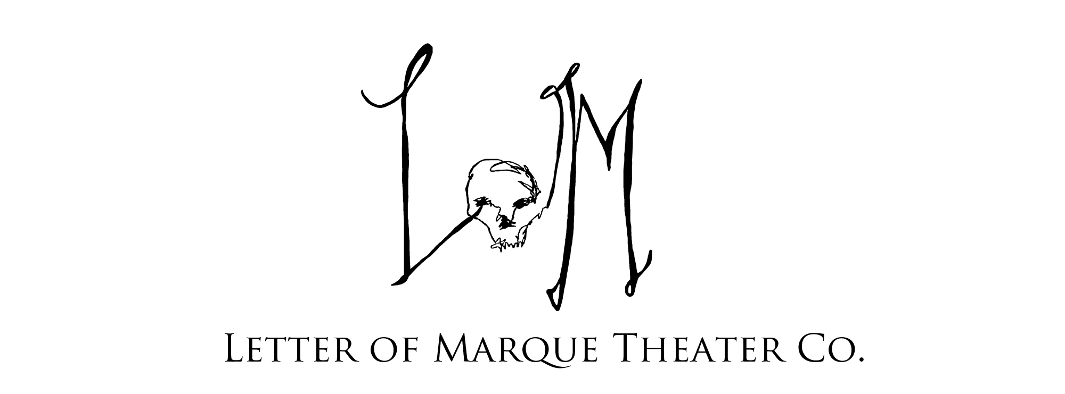
Letter of Marque Theater Company
261 Douglass Street
Brooklyn, NY 11217

www.lomtheater.org

+1 (718) 246 2211
letterofmarqueco@gmail.com
facebook.com/LetterofMarque
@LOMTheater

Dear Neighbor,
With great excitement, we’d like to invite you to LOM Theater’s End of Season Party! This marks the completion of our first season as an ensemble theater company here in Gowanus, Brooklyn. For the past 12 months we have been building and working towards establishing a working community of Brooklyn artists to make new and re-imagined, dynamic theater accessible and approachable to all.

We would love to invite you, your team and associates to our party “Fortune’s Take – A Casino Carnivale” happening on Saturday, June 21st at Littlefield (622 Degraw St, Brooklyn). We will have live music – 3 bands and a DJ – swordfights, a pop-up casino, raffle prizes and more! If you could promptly finish this letter and RSVP on our website, Facebook, via phone or email and let us know how many of your employees you’d like to bring along. We would love to meet and share the love with everyone who makes this neighborhood what it is!
Also in the spirit of community we are looking for donations for our raffle or silent auction. This is a great opportunity for our network to engage with your business, and your logo and brand will be listed as a sponsor in our programs, website, social media and included for discounts for future events….and did we mention the free drink tickets?
We’re talkin’ something fun, something valuable, something silly, something helpful. Whatever contribution lets our community know how great your business is. Gift certificates, coupons, products, services, anything you’d like. Our goal is to get 24 prizes to aim for another 12 months of successful ensemble driven art!
Most important, though, is that you join us. There will be live music and performances, drinks and fun, laughing and revelry, old friends and new friends, celebration and a great thanksgiving to our work, to our community and to you, our Brooklyn.

Please include the attached donation form and the names you’d like on your guest list.

Sincerely, your neighbor,

Scarlet Maressa Rivera, Welland H. Scripps, Nolan Kennedy
The Letter of Marque Theater Company
Letter of Marque Theater Company
261 Douglass Street
Brooklyn, NY 11217

www.lomtheater.org

+1 (718) 246 2211
letterofmarqueco@gmail.com
facebook.com/LetterofMarque
@LOMTheater

FORTUNE’S TAKE DONATIONS

Join us in celebrating LOM Theater Company’s End of Season Party and offer support in our programs by making a donation to our Raffle or Silent Auction prizes. Guests will be an eclectic mix of artists, business owners and entrepreneurs aged 25 to 65 years based in Brooklyn and wider New York.

Our event will be taking place at Littefield (622 Degraw Street, Brooklyn) on Saturday the 21st of June. The event, “FORTUNE’S TAKE” is a Pirate Casino Carnivale featuring a spectacular night of performances, live music, a pop-up casino, VIP Lounge, catering by Runner and Stone and more!

Donations of products and services are a
wonderful way to showcase your business to new clientele,
gaining terrific exposure to the 200+ attendees at our event!

In return for your donation, you and your company will receive

1x Powder Monkey Open Bar Ticket (valued at $45),
for the Fortune’s Take event on Saturday, June 21st at Littlefield.

Brand and Logo placement of your
product or promotional materials at the
Raffle and Auction display at Fortune’s Take

Brand or Name Credit in the Event Program

Social Media Mentions and
Links on the donations page on our official website
www.lomtheater.org

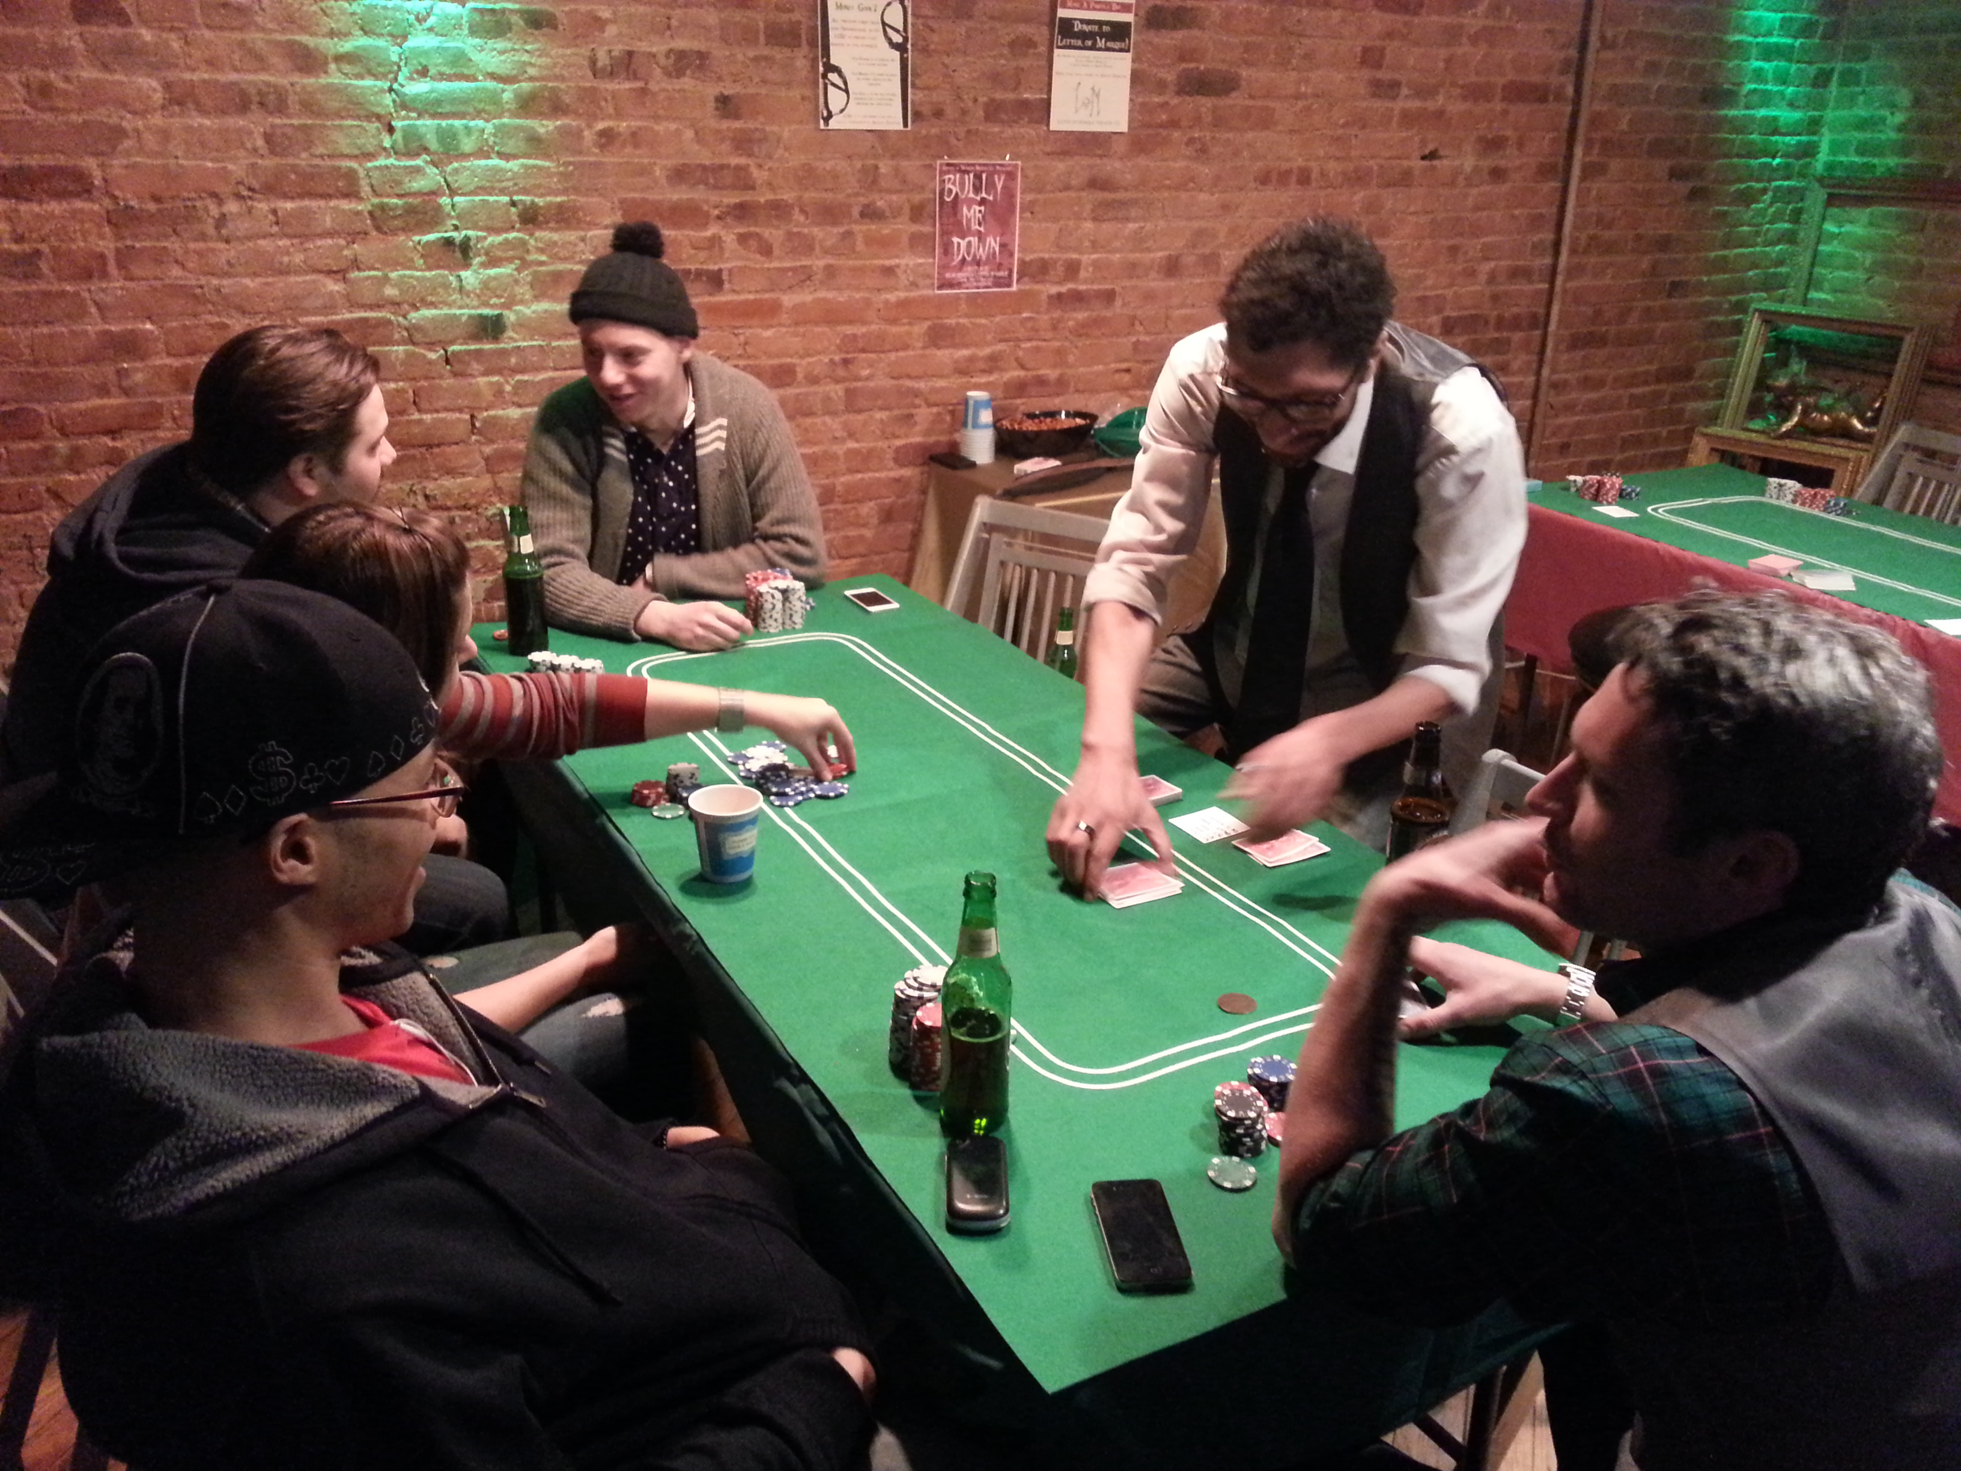
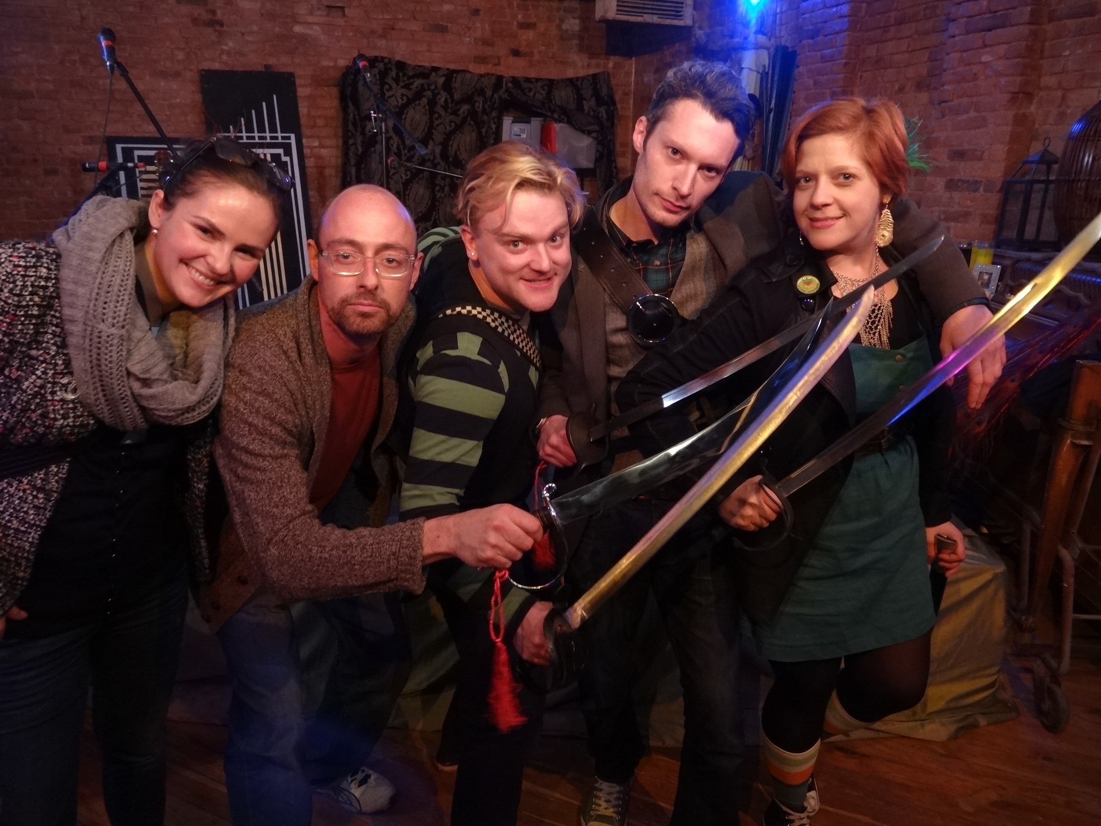
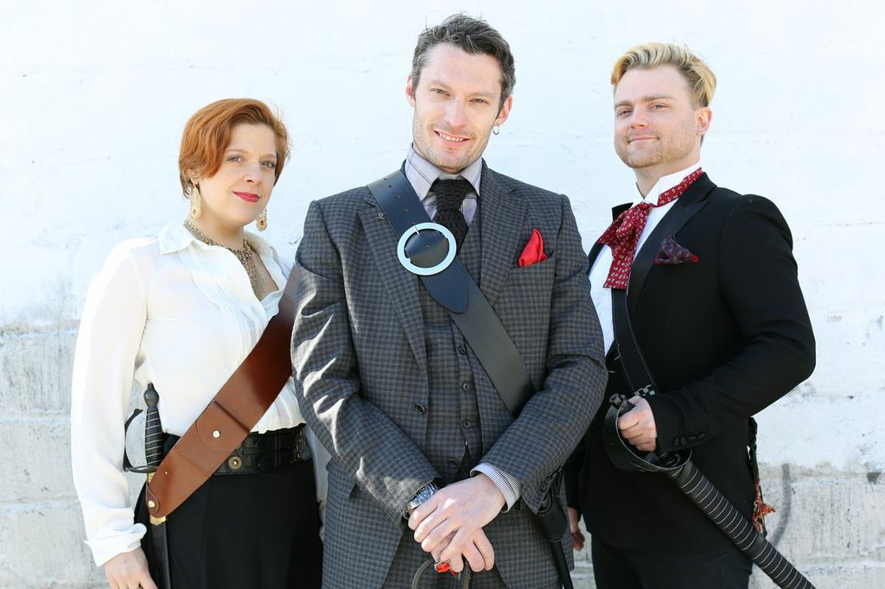

Letter of Marque Theater Company
261 Douglass Street
Brooklyn, NY 11217

www.lomtheater.org

+1 (718) 246 2211
letterofmarqueco@gmail.com
facebook.com/LetterofMarque
@LOMTheater

FORTUNE’S TAKE DONATION FORM

Name: ________________________________________________

Company: ______________________________________________

Address: _______________________________________________

City:_______________________ State: _____ Zip: _____________

Phone: ____________________ Email: ______________________

Description of Donated Item:

Approximate Value: ______________________________________
(Donations are tax deductible as allowed by law)

Name we should credit on donations page / event program

If you have any additional questions about the raffle,
please contact Karen Ng via email on letterofmarqueco@gmail.com
or phone (718) 246 2211.

